Proof of ownership:
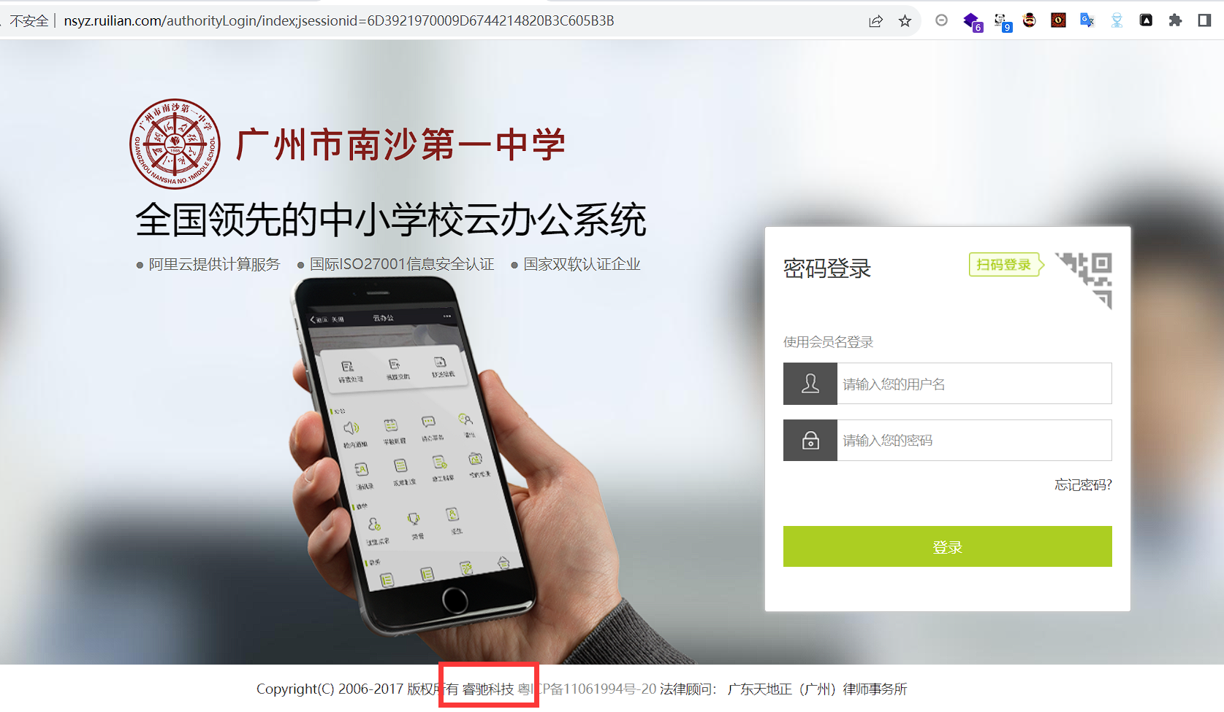
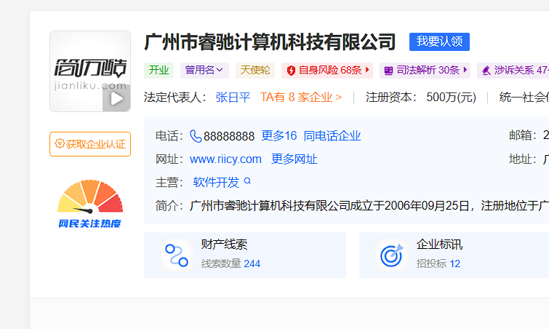

Vulnerability recurrence:
URL：http://nsyz.ruilian.com/
1.Heapdump Document disclosure
http://nsyz.ruilian.com:80/heapdump.json
Download the heapdump
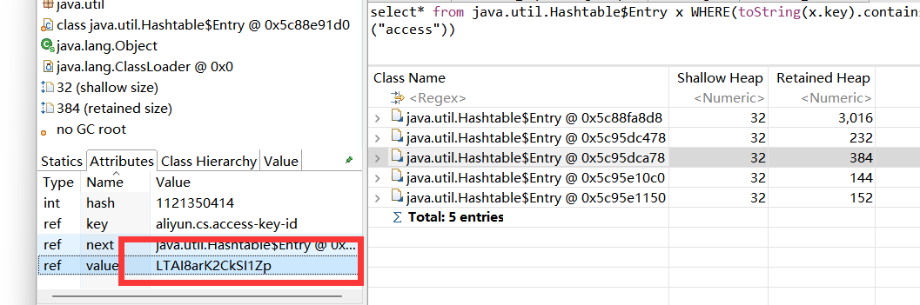
Get the keys
Access-key：LTAI8arK2CkSI1Zp
Access-secret：eBOo00g8lFFSoAQy65aPJywNR3BVE9
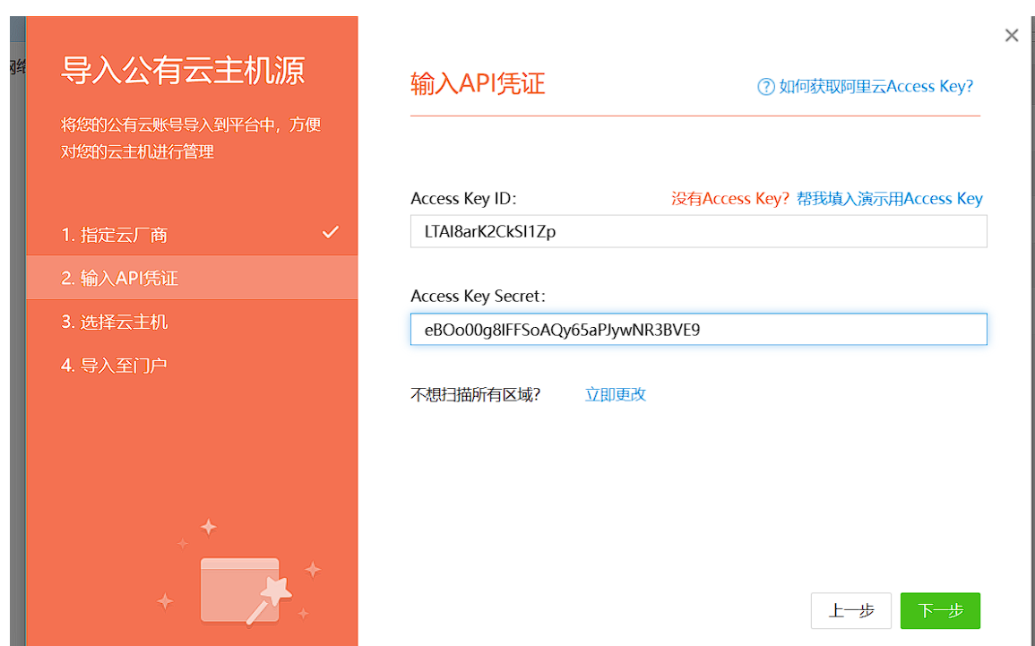

The leak of some important passwords

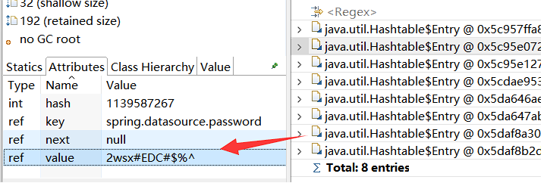

http://nsyz.ruilian.com/logfile
- Server log information is leaked
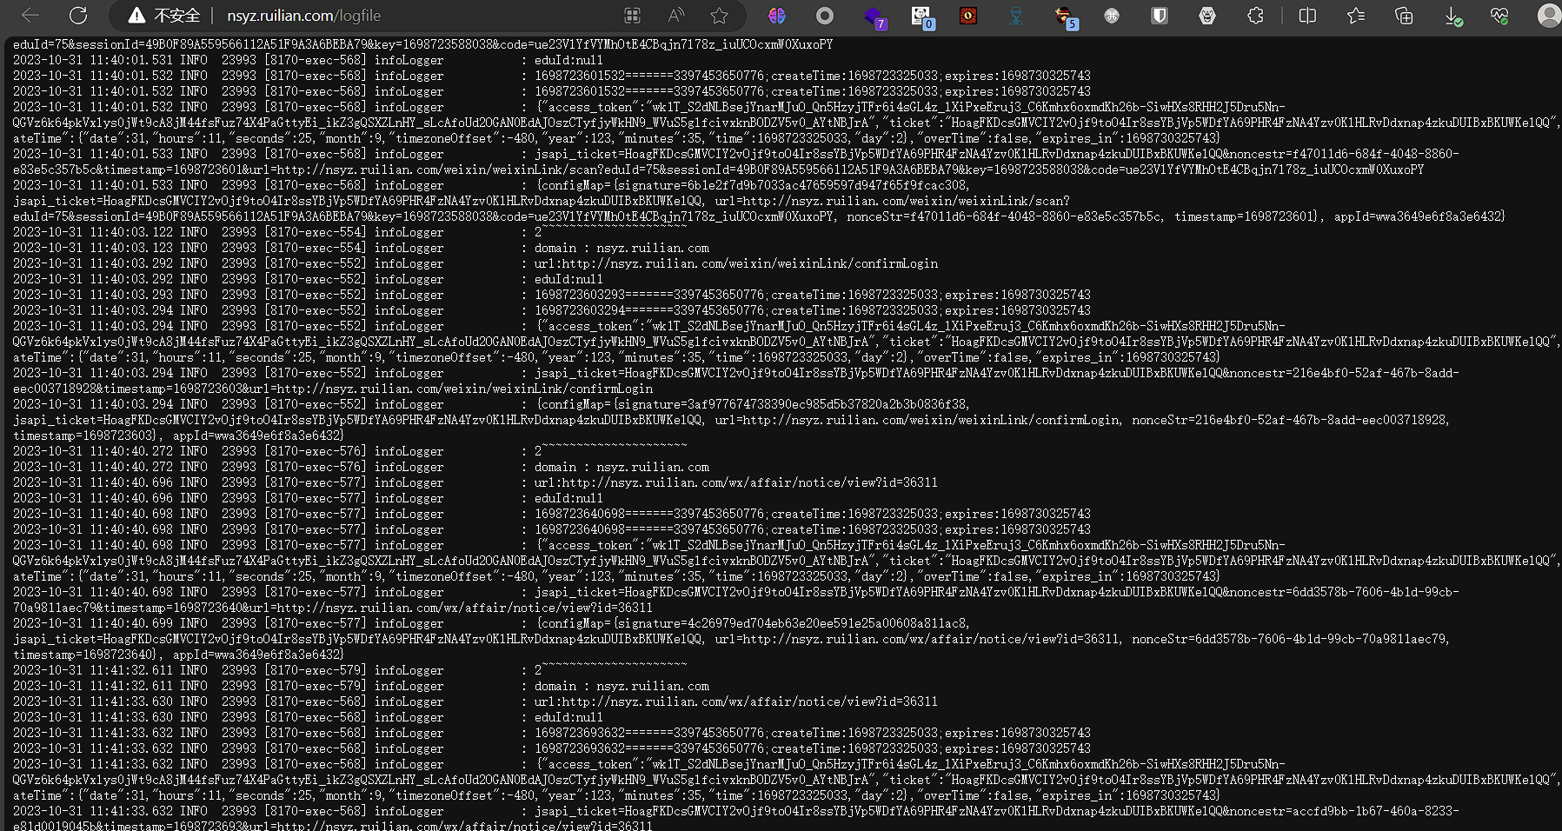
Appid and appsecret access-token disclosure
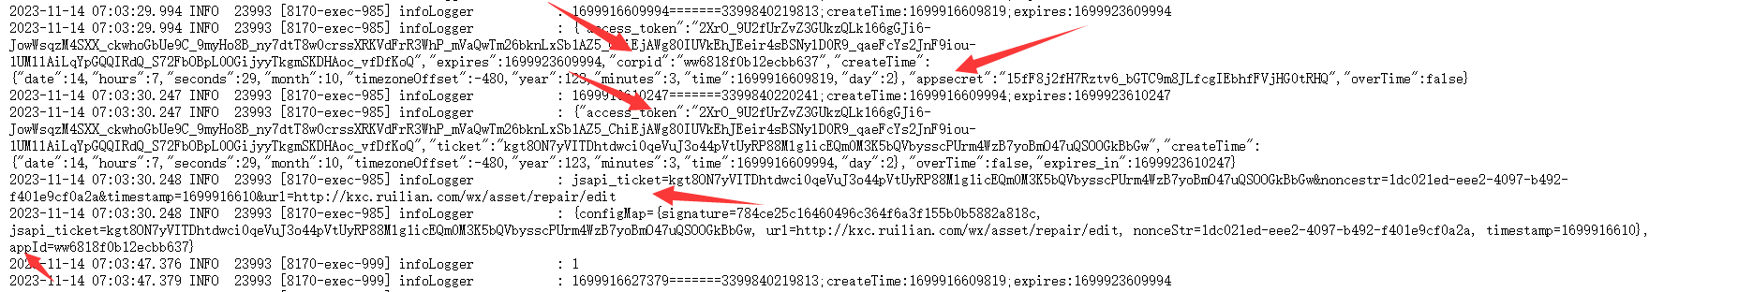
Other examples
They all have the above loopholes

http://gdfx.ruilian.com/
http://newsys.ruilian.com/
http://yucai.ruilian.com/
http://kxc.ruilian.com/
http://zyzx.ruilian.com/
http://nsxx.ruilian.com/
http://bjhf.ruilian.com/
http://meilun.ruilian.com/

